Global variables
The variables created outside the function are called global variables. These are global to module/program. These variables can be used inside one or more than one functions.
In application development global variables are used to share data between number of functions.

Syntax:
global-variable1=value
global-variable2=value
def function-name([parameters]):
local-variable-name=value
local-variable-name=value
def function-name([parameters]):
local-variable-name=value
local-variable-name=value

Example:
def add():
print(f'Sum of {a} and {b} is {a+b}')
def sub():
print(f'Diff of {a} and {b} is {a-b}')
def multiply():
print(f'Product of {a} and {b} is {a*b}')

#Main
a=100 # Global Variable
b=200 # Global Variable
add()
sub()
multiply()

Output
Sum of 100 and 200 is 300
Diff of 100 and 200 is -100
Product of 100 and 200 is 20000

Global variables must be created before calling the function.

def add():
print(f'Sum of {a} and {b} is {a+b}')
def sub():
print(f'Diff of {a} and {b} is {a-b}')
def multiply():
print(f'Product of {a} and {b} is {a*b}')

#Main
a=100 # Global Variable

add()
b=200 # Global Variable
sub()
multiply()

Output
Traceback (most recent call last):
File "D:/Backup/Python7PMOCT/test278.py", line 11, in <module>
add()
File "D:/Backup/Python7PMOCT/test278.py", line 2, in add
print(f'Sum of {a} and {b} is {a+b}')
NameError: name 'b' is not defined

Example:
x=100 # Global Variable
def fun1():
y=200 # Local Variable
print(f'Local variable y={y}')
print(f'Global variable x={x}')

def fun2():
x=300 # Local Variable
print(f'Local variable x={x}')

fun1()
fun2()
fun1()

Output
Local variable y=200
Global variable x=100
Local variable x=300
Local variable y=200
Global variable x=100

A function can access global variable directly but a function cannot modify or update value of global variable directly.

global keyword

“global” is a keyword, which is used to modify or update value of global variable with function.

Syntax:
global variable1,variable2,variable3

after this statement, list variable names are treated as global variables.

Example:
x=100 # global variable
def fun1():
print(x)
def fun2():
x=300 # Local variable
print(x)
def fun3():
global x
x=600
print(x)

fun1()
fun2()
fun3()
fun1()

Output
100
300
600
600

Example:
# finding area of triangle
base=0.0 # Global Variable
height=0.0 # Global Variable
def read():
global base,height
base=float(input("Enter Base of Triangle "))
height=float(input("Enter Height of Triangle "))

def find_area():
area=0.5*base*height
print(f'Area of triangle is {area:.2f}')

read()
find_area()

Output
Enter Base of Triangle 1.2
Enter Height of Triangle 1.5
Area of triangle is 0.90

The listed variables of global statement should not be before global statement.

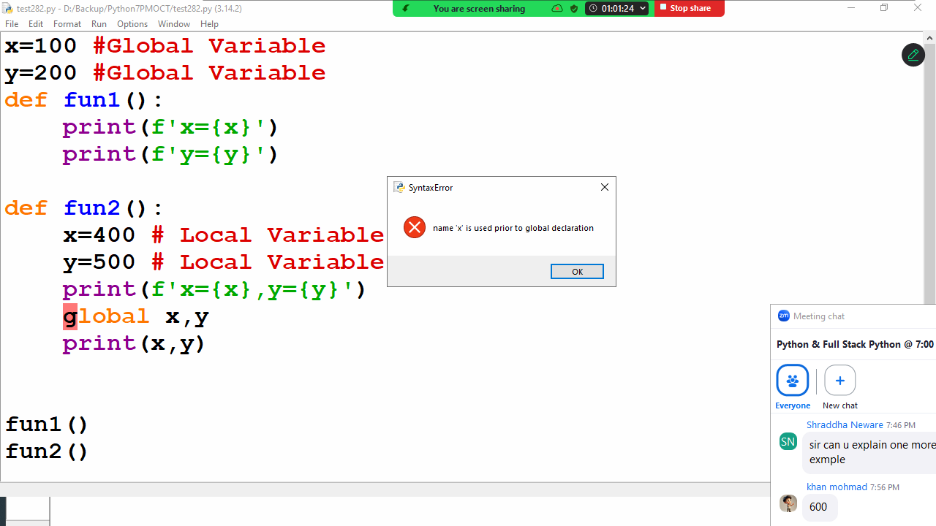

globals()
Return the dictionary implementing the current module namespace. For code within functions, this is set when the function is defined and remains the same regardless of where the function is called.

Example
x=100 #Global Variable
y=200 #Global Variable
def fun1():
print(f'x={x}')
print(f'y={y}')

def fun2():
x=400 # Local Variable
y=500 # Local Variable
print(f'Local x={x},Local y={y}')
d=globals()
print(f"Global x={d['x']},Global y={d['y']}")
d['x']=700
d['y']=800

fun1()
fun2()
fun1()

Output
x=100
y=200
Local x=400,Local y=500
Global x=100,Global y=200
x=700
y=800

Function with parameters or arguments

Function without parameters does not receives values
Function with parameters receives values
In application development a function defined with parameters to receive input/values in order to perform operation.
Python allows writing a function with 3 types of parameters/arguments.

- Function required parameters/arguments
  - Function with required positional arguments
  - Function with keyword arguments
- Function with default parameters/arguments
- Function with variable length parameters/arguments
  - Function with positional variable length arguments
  - Function with keyword variable length arguments

Parameters are local variables, which are used only within function but cannot accessible outside the function.

Function required parameters/arguments
If function is defined with required parameters, those parameters required values at the time of invoking function or calling function.

Syntax:
def function-name(param1,param2,param3,…):
statement-1
statement-2

Example:
def fun1(a,b,c): # required parameters
print(a,b,c,sep="\n")

fun1(100,200,300)
fun1(10,20,30) # Positional arguments
fun1(1,2,3)
fun1(a=100,b=200,c=300) # Keyword arguments
fun1(b=99,a=88,c=44) #Keyword arguments

Output
100
200
300
10
20
30
1
2
3
100
200
300
88
99
44

A function with required parameters receive values in 2 ways
- Using parameter positions
- Using parameter names (Keyword arguments)

